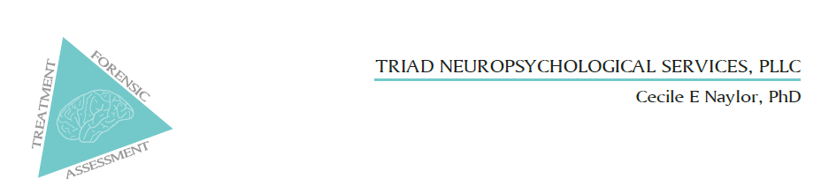
Referral Form
Fax this form to: (336)922-3206 or email dr.naylor@triadnps.com
Dr. Naylor provides evaluations and therapy to adults and children, including worker’s comp cases.

INSURANCE:
- Dr. Naylor is ONLY paneled with Carolina Behavioral Health Alliance, the mental health provider of those insured with Wake Forest University and the Atrium/WFU hospital system.
- Dr. Naylor is out of network for other insurance groups and is not a Medicaid/Medicare provider.

Referring Office: ___________________________________________________________________

Physician & Specialty: ________________________________________________________________

Patient being referred for: _____ Neuropsychological Assessment ____ Cognitive Treatment

Reason for Referral: ______________________________________________________________

_________________________________________________________________________________

Differential / Rule Out Diagnoses: ___________________________________________________

_________________________________________________________________________________

Patient Name: _______________________________________________ DOB: _______________

Patient Ph Nbrs: ___________________________________________________________________

Patient Email: ____________________________________________________________________

Patient Insurance: ______ Atrium Hlth/Wake Forest Univ insurance (likely covered)

______ Other insurance (not covered) _____ Medicare/Medicaid (not covered)

Reply back instructions/contact: _____________________________________________________
_________________________________________________________________________________
Thank you for your referral.

Please fax this form to: (336)922-3206 or email dr.naylor@triadnps.com

